Complaints and Compliments Policy

- Introduction
At Worthing Dental Centre we take complaints very seriously and try to ensure that all our patients are pleased with their experience of our service. When patients complain, they are dealt with courteously and promptly so that the matter is resolved as quickly as possible. This policy and procedure is based on these objectives. We learn from every mistake that we make and we respond to patients concerns in a caring and sensitive way. We have a named staff member responsible for dealing with any complaint about the service which we provide.

At Worthing Dental Centre we are constantly striving to improve, to provide an exceptional service. Feedback is an essential part of this, so if you have suggestions about how we could improve then please let us know. We would also appreciate any compliments about our service, as these can also be used to continue to improve and provide the best possible service to our patients.

- Purpose
This policy aims to enable Worthing Dental Centre to establish and operate systems for identifying, receiving, recording, handling and responding to complaints & compliments. As a result of following these procedures Worthing Dental Centre will investigate and take necessary proportionate action in response to any failure identified by a complainant or investigation. We will ensure that:
- Patients know how to complain and that their comments and complaints are effectively listened to and acted upon.
- Patients know that they will not be discriminated against for making a complaint.
- Patients feel confident and comfortable in voicing their complaints and concerns.
- Complaints & Compliments are treated as learning opportunities and also as an opportunity to improve care procedures.
- Patients know how to provide feedback, suggestions and compliments.
The Registered Provider must establish and operate an effective and accessible complaints & compliments system. The Complaints Manager (or Lead) should ensure that practice policies are followed, records kept, significant event analysis completed, and all audit, review and reporting procedures are followed. They also should ensure that staff training on complaints management is included in new staff inductions and that team training is regularly refreshed (see Complaints Lead Job Description).

- Scope
- Registered Provider.
- Registered Manager and/or Complaints Lead.
- Patients
- Relatives/Guardians, where appropriate.
- Other professionals outside agencies.
- All employees.

- Policy
It is the policy of this practice to ensure that:
- There is a clear complaints procedure in place, which is available to patients in the public areas of Worthing Dental Centre
- There is a clear compliments/feedback/suggestions procedure in place, which is available to patients in the public areas of Worthing Dental Centre
- Complaints Lead has responsibility for collating, responding and investigating complaints.
- The Complaints Manager has responsibility for ensuring the team has induction training followed up with regular updates in complaints handling.
- The Complaints Manager has responsibility for ensuring the complaints procedure is carried out correctly.
- It is clear from the procedure that the complaints will be dealt with respectfully and without prejudice.
- Patients are kept informed of the timescale and at each stage of the handling of a complaint.
- The procedure makes it clear what they should do if they are not happy with the result of a complaint. Contact details for the relevant commissioning body such as NHS England or a local CCG and PALS service should be on display.
- If it becomes clear that litigation, or the intent, has started then the complaints procedure may be terminated.
- Worthing Dental Centre will cooperate with any further investigation by the relevant commissioning body or any involvement by a recognized organization such as PALS.
- When treatment is made under referral, or treatment is transferred to another provider, Patients are made aware of the complaints system worked by all providers as far as possible.
- Consent and confidentiality must not be compromised during the complaint process unless there are professional or statutory obligations, such as safeguarding, that make this necessary.

- Procedures & Protocols
To meet these policy requirements Worthing Dental Centre will observe the following procedures:

Identifying and Receiving Complaints
- Patients may raise concerns to any member of staff, verbally or in writing.
- They will be directed to Worthing Dental Centre’s Complaints Lead to hear them, or to address a written concern. (If the complaint is regarding treatment then the complaint will be passed to the treating dentist to investigate).
- In all cases an acknowledgement will be raised in writing and provided to the complainant within three working days, together with a copy of the Complaints Procedure if this has not been obtained before.
- The reply will give an estimate of the time required to investigate the complaint and reply again, which would normally be within ten working days and no later than twenty days.
- A written response, including the result of investigation, will be issued to the patient at that time. If this is not possible, the patient will be informed in writing why, and a new time frame issued.
- Written documentation is retained.
- Patients are informed of the address of the relevant commissioning body, PALS, Health Ombudsman and the GDC should they wish further information or address.
- All complaints are recorded on a complaints record sheet. Regular review of complaints records will assist the Management team in identifying any trends.
- All complaints will be acknowledged in writing within 3 working days. Complainants will be replied to within 10 working days of the complaint arising or we will give an estimate of the time required to investigate the complaint and the complainant will be given the opportunity to agree an alternative timescale if needed.
- The response will substantiate or not substantiate all points made and give a detailed outcome response with all actions to be taken to resolve issues that have been raised.

Investigating the Complaint
- Investigations and the related results will be recorded on the complaints form, including additional sheets, if required.
- Complaints will be investigated in the first instance by the Practice Manager/Complaints Lead, and referred up the chain of management as necessary to reach a satisfactory outcome for the complainant. (If the complaint is regarding treatment then the complaint will be passed to the treating dentist to investigate). The Registered Manager will become aware of the matters dealt with by other persons by way of the regular review of the file.
- The Registered Manager will take corrective action if it is felt during this review that complaints are not being appropriately referred up the line of management.
- The person investigating the complaint should gather the information or evidence necessary to fully understand the complainant's concerns. This may include reviewing additional records or speaking to any witnesses.

Recording the Complaint
- All employees are warned that written complaints recording rules must be complied with, and those records held where they are freely available to supervisors and managers. Any attempt to conceal a complaint may give rise to formal disciplinary action.
- The complainant will be requested to examine the written records of the complaint and sign to indicate agreement with the outcome.
- Records must be kept of all complaints, including those for which no actions were considered necessary after a full and fair investigation.
- In the event of a continued disagreement which cannot be resolved internally, the complainant will be advised to approach an appropriate external authority, such as the CQC, funding authorities such as Social Services or NHS, an independent advocacy service or the Local Government and Social Care Ombudsman.
- The completed complaints form will then be handed to the Registered Manager nominated Complaints Lead for permanent filing, in the complaints file.
- The Management Meeting will periodically (recommended every three months) review all complaints and significant event analysis carried out since the previous review, in order to identify trends and matters which may have appeared to be relatively minor at the time, but which indicate a deeper problem.
- The services action plan should be updated to include all actions to be taken to resolve any requirements or recommendations made following any investigation.
- The records are kept and provided to CQC at any time that they may ask for them.

Complaints Analysis - Following a full and fair investigation
- The Complaints Lead will conduct a significant event analysis (SEA) for each complaint received.
- Findings from the SEA will be presented at a policy review meeting to make recommendations to improve services.
- A full report of the SEA findings along with recommendations to prevent recurrences will be presented to the Registered Provider and after full consideration of the recommendations agreed, relevant policy changes will be made and the team updated.
- Measures taken to improve services will be reviewed on an ongoing basis to ensure that improvements have been maintained.

Duty of Candour
- If the complaint is a notifiable incident, as per the Duty of Candour Policy and Procedure, we shall follow that procedure as indicated.
Staff Training
- This practice will ensure that every team member is familiar with Worthing Dental Centre complaints procedure.
- We will provide initial training and regular updates to ensure staff can deal with patients concerns and complaints, and know how to apologise and offer practical solutions.

KEY CONTACTS FOR NHS PATIENTS
Care Quality Commission (CQC)
CQC National Customer Service Centre
Citygate
Gallowgate
Newcastle upon Tyne
NE1 4PA
Telephone: 03000 616161
Fax: 03000 616171

Clinical Commissioning Group The Local Government Ombudsman
PO Box 4771
Coventry CV4 0EH
Telephone: 0345 015 4033 or 0300 061 0614
Fax: 0300 061 4000
advice@lgo.org.uk

FOR PRIVATE PATIENTS
Dental Complaints Service: https://dcs.gdc-uk.org/
Helpline 0345 015 4033
The Independent Sector Complaints Adjudication Service (ISCAS)
ISCAS,
CEDR, 3rd Floor
100 St. Paul’s Churchyard
London
EC4M 8BU
Phone: 020 7536 6091
info@iscas.org.uk

RELATED GUIDELINES & REGULATIONS
The Local Authority Social Services & NHS complaints (England) Regulations 2009: https://www.legislation.gov.uk/uksi/2009/309/contents/made

GDC Complaint handling best practice: https://www.gdc-uk.org/information-standards-guidance/standards-and-guidance/complaint-handling

CQC Dental mythbuster 34: Complaints management: https://www.cqc.org.uk/guidance-providers/primary-medical-services/dental-mythbuster-34-complaints-management

NHS PALS: https://www.nhs.uk/nhs-services/hospitals/what-is-pals-patient-advice-and-liaison-service/

Parliamentary and Health Service Ombudsman: https://www.ombudsman.org.uk/

CQC Statement on dental complaints: https://www.cqc.org.uk/sites/default/files/20181050_statement_on_dental_complaints.pdf

Data Protection Act 2018

The General Data Protection Regulation

Public Interest Disclosure Act 1998

CQC Complain about a service or provider: https://www.cqc.org.uk/contact-us/how-complain/complain-about-service-or-provider

Policy Details
Practice Information: (NHS/Private) | NHS
Practice Manager Name: | Kirstie Knight/Anna Strudwick
Practice Name: | Worthing Dental Centre
Version: | 2.2
Update Date: | 30.06.2022
Review Date: | 30.06.2023
Author: | Smart Dental Compliance & Training
Mandatory/Recommended Policy: | Mandatory

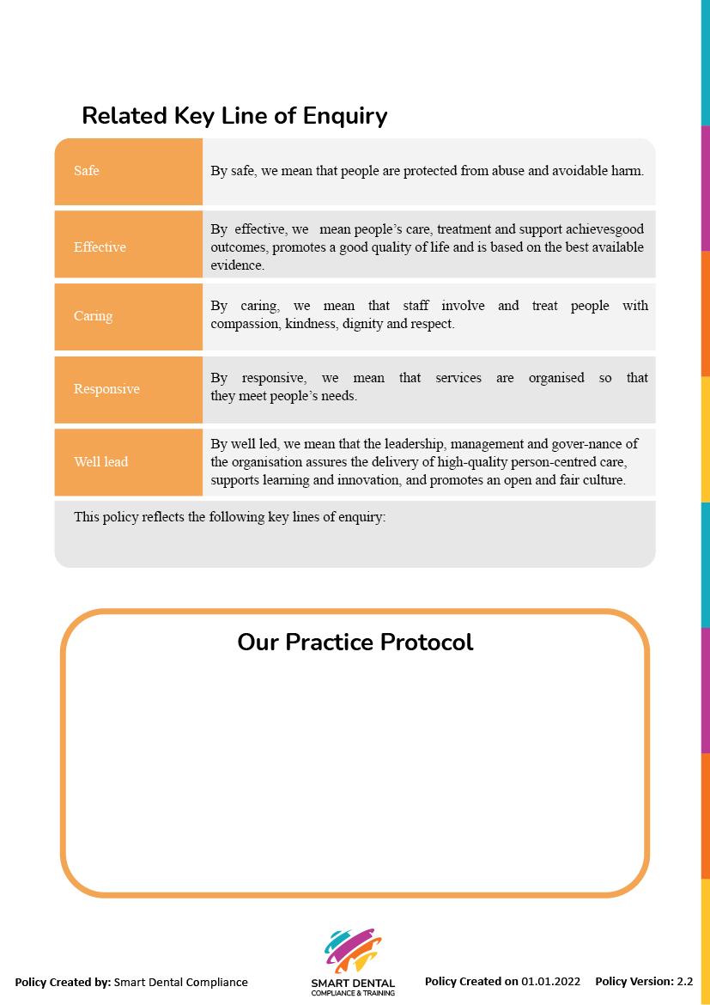
- The name of our registered manager or complaints lead is: Kirstie Knight
- We have the following methods for patients to provide feedback: questionaires, leaflets, surveys, these are located in: the waiting rooms
- Lessons learned from complaints/feedback etc
- Staff training
- Location of complaints record sheets – Complaints folder in filing cabinet in hallway behind reception

Responsive

